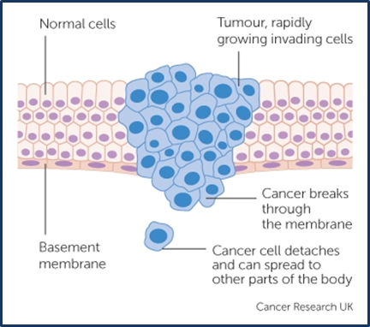
If you ask everyone you know “What is cancer?” you’ll probably get a different answer from everyone. Cancer is actually a collection of diseases, so there’s no single disease called “cancer.” Which is one reason that there are so many different impressions of the disease. Fear is another reason—a lot of people simply don’t like to talk about cancer.
But awareness is one of your strongest defenses. Which is why, in the weeks ahead, we want to open up a conversation about cancer.
Let’s start with a fairly basic definition of cancer. Most cancers share this characteristic: cancer starts as normal cells that begin to act in abnormal ways.
One of these abnormalities is that cancer cells don’t die like normal cells do.¹ Either they don’t get (or they ignore) the message that tells them to die.1 (Cell death is a natural process by which the body gets rid of unneeded cells).¹ Instead, cancer cells continue replicating themselves—one cell divides and becomes two.¹ Those two cells divide again and divide again.¹
And so the cancer grows (as illustrated in the figure from Cancer Research UK). Here are some other things to know about how cancer behaves:¹
- The human body is made up of trillions of cells, so cancer can start almost anywhere.
- Where normal cells are specialized (they have specific functions in the body), cancer cells don't have specific functions. This is one reason they continue to divide without stopping.
- As cancer cells grow, they can form a malignant mass or tumor. Malignant tumors can invade surrounding tissues. Cancer that has a chance to spread beyond its point of origin is harder to treat.
- With some cancers, cells can break off from the original tumor and travel through the blood or the lymph system to invade another part of the body. This is called a metastatic tumor.
Not all changes in the body’s tissue are cancer. Not all cancers are characterized by hard masses or tumors. And not all tumors are malignant. But in this campaign, we’re focusing on three cancers which can be detected early with health education, awareness, and/or screening. The three cancers are: breast, skin, and colon cancer.
Researchers have learned an incredible amount about how cancer behaves. But there’s still so much that the medical community doesn’t know: causes we don’t understand; cures we don’t yet have. But what we do know can save your life.

http://www.who.int/mediacentre/factsheets/fs297/en/
http://www.cancerresearchuk.org/about-cancer/causes-of-cancer/sun-uv-and-cancer/ways-to-enjoy-the-sun-safely

